2024-2025 Corner Brook Firefighter Recruitment

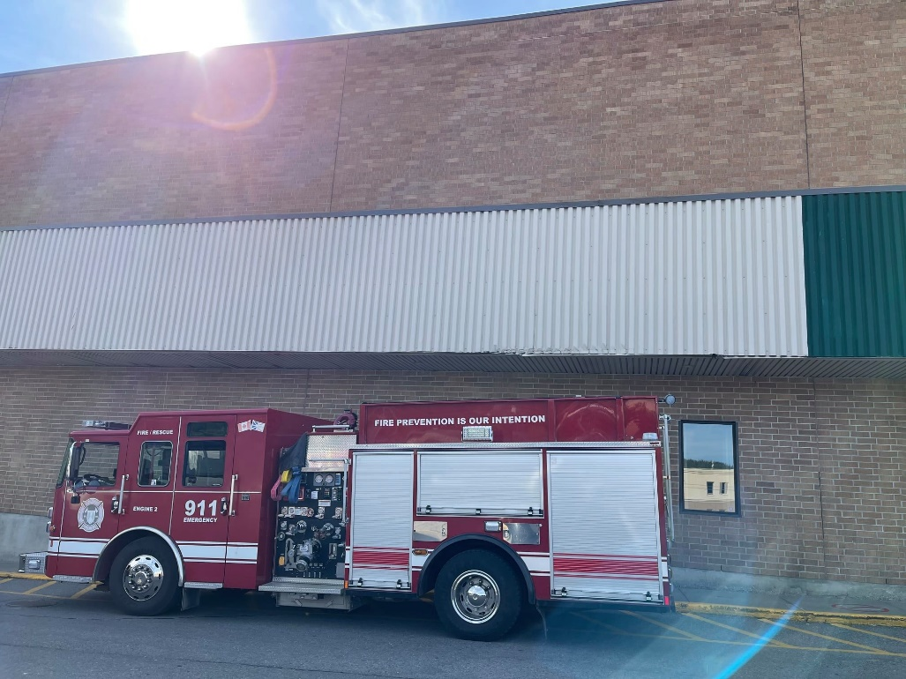

City of Corner Brook

5 Park Street

Corner Brook, NL A2H 6E1

***The City of Corner Brook is committed to hiring and maintaining an inclusive and diverse workforce. We encourage applicants from under-represented groups, Indigenous peoples, members of racialized minority groups, persons with disabilities, women, and persons belonging to sexual orientation and/or gender identity minority groups, to self-identify on their application.***

**INTRODUCTION**

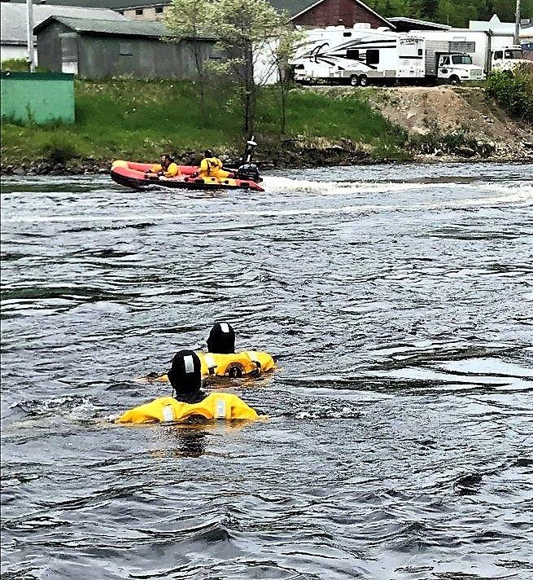The Corner Brook Fire Department (CBFD) consists of four Platoons comprised of 9 firefighters per platoon. The Fire Department personnel are trained and committed to providing high quality, efficient, and effective emergency services to those in the City of Corner Brook and in certain cases, the surrounding area.

With CBFD’s more than sixty years of service to the community they show their commitment to fire safety in both emergency and non-emergency situations.

Services provided to the public include, but are not limited to:

* Fire Suppression
* 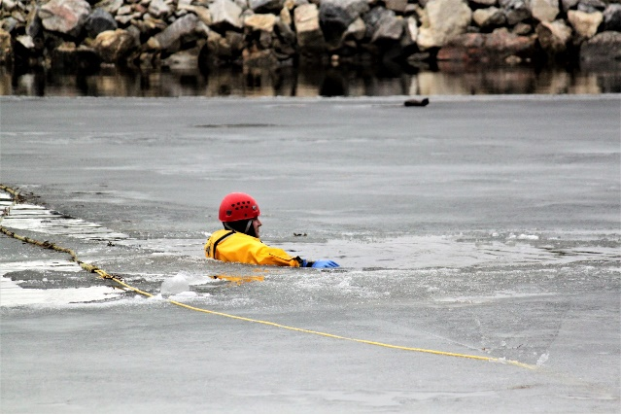Road Traffic Accident Response
* Medical Response
* Hazardous Materials Response
* Rapid Water Response
* High Angle Response
* Fire Prevention

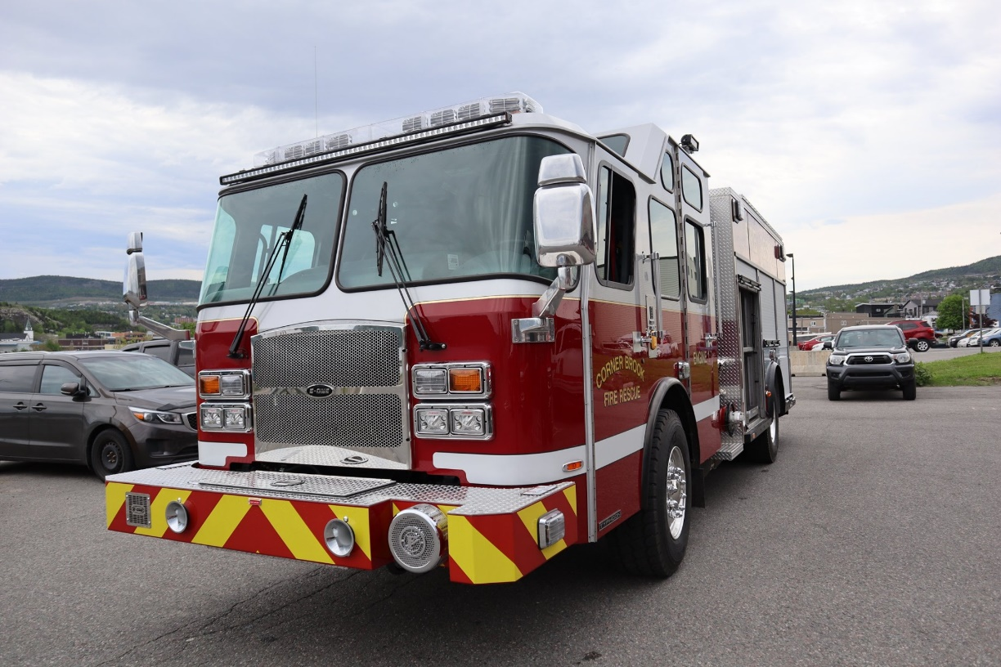

**STRUCTURE**

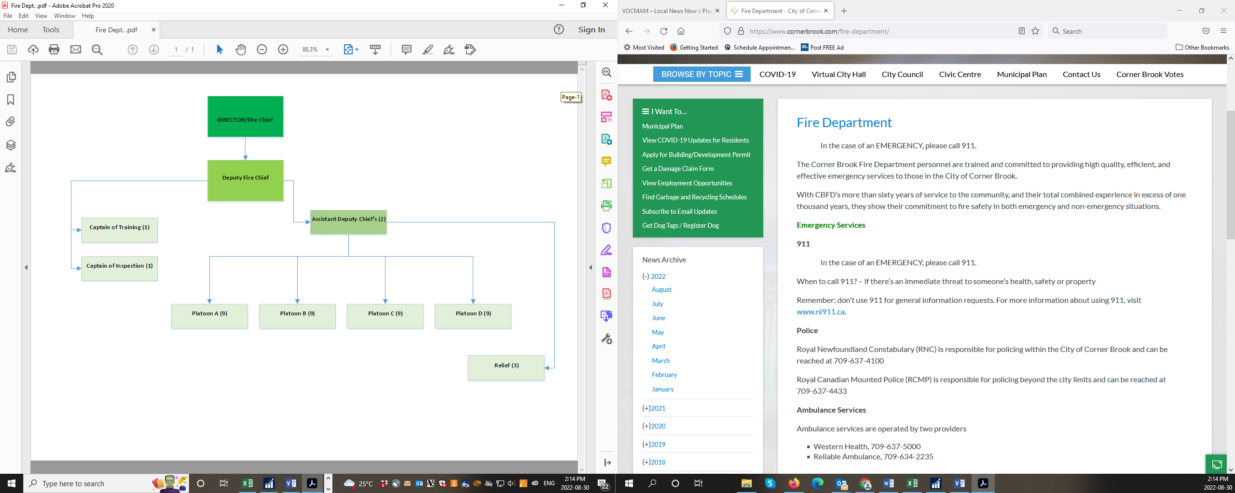The Fire Chief (Director of Protective Services) is responsible for providing Corner Brook with an acceptable level of fire and emergency protection in the most economical manner. The Director is located in City Hall.

The CBFD is staffed 24 hours a day to respond to emergency calls. In addition to emergency response which includes fire, vehicle, and medical emergencies the Fire Department also offers Speciality Teams ready to respond to incidents that include: High Angle Rescue, Water Rescue, Confined Space, and Hazardous Materials Emergencies.

In addition to providing emergency response the CBFD is proactive with conducting pre-fire planning, community education sessions, and inventories of hazardous information and materials.

Currently servicing the community is one Fire station, located on 116 Broadway. The station is operated by a minimum of 7 full time firefighters 24 hours a day.

**TRAINING**

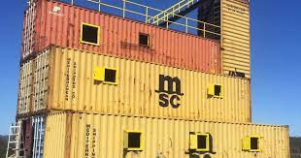Reporting directly to the Deputy Fire Chief the training officer is responsible for the development, implementation, and administration of a comprehensive training and evaluation program for fire-rescue personnel. Training of CBFD firefighters takes place in a classroom setting as well as the field setting. CBFD is proud to train in its newly constructed training facility which presents opportunity for live burn scenarios, use of different equipment and nozzles, different spray patters, etc.

**DISPATCH | 911 PUBLIC SAFETY ANSWERING POINT**

The province’s 911 Public Safety Answering Point (PSAP) is operated by the City of Corner Brook and along with their provincial emergency 911 duties, they provide the dispatch services to the City of Corner Brook and the Town of Stephenville Fire (SFD) Departments. Our PSAP Call-Takers double as Dispatchers for the CBFD and the SFD.



# RECRUITMENT PROCESS

Welcome to the City of Corner Brook’s Fire Department (CBFD) Relief Firefighter Recruitment and Selection Process. The information contained in this handbook will outline the recruitment and selection process as well as the duties, expectations, responsibilities and challenges associated with being a CBFD firefighter.

The need to hire new recruits is evaluated throughout the year and there is no set date for recruitment as it is based on staffing needs. Once recruitment needs become a priority an advertisement is release for Relief Firefighters. The advertisement will be posted on the City of Corner Brook’s webpage as well as on Indeed.

Applications will not be accepted until a posting has been advertised

The following information should be read in its entirety. At any time and without prior notice, the City has the right to change and/or amend any of the steps in the recruitment process as outlined below. All changes will be consistent for any given recruitment, meaning that all candidates during a given recruitment drive will be subject to the same revisions.

Failure to adhere to the information outlined in this document, including deadlines, will result in disqualification from the recruitment and selection process and you will not be considered for employment.

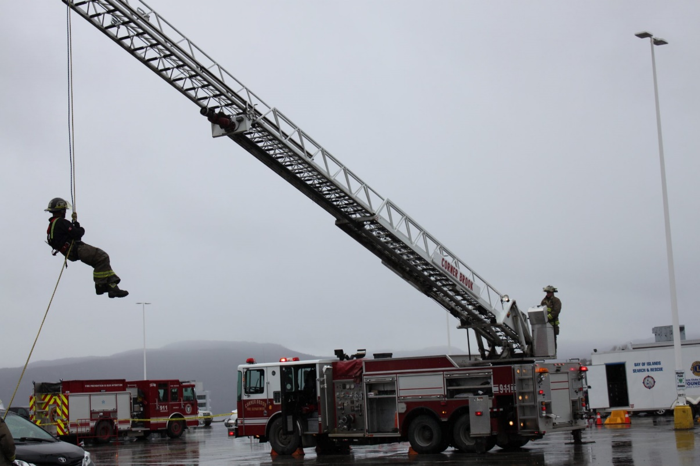

**WHAT DOES IT TAKE TO BECOME A FIREFIGHTER?**

Firefighting is a physically and mentally demanding occupation. Firefighters are continuously training and absorbing new information and education. The profession requires individuals that are willing to put themselves in harms way in order to protect life and property.

The information contained within this guide should help you to decide if you have what it takes to pursue a career in firefighting. A large part of becoming proficient in the firefighting field involves handling various specialized tools and operating specialized equipment. The skill and precision involved with firefighting and emergency response tasks takes practice, determination, and persistence.

**WHAT QUALIFICATIONS DO I NEED TO BECOME A FIREFIGHTER?**

Interested individuals must possess the minimum qualifications as outlined below. Those meeting the qualifications are encouraged to apply for a relief position with CBFD when advertised.

* Certificate from an IFSAC accredited institution in NFPA 1001, Level II
* Medically and Physically fit to meet the City’s requirement related to firefighting
* Successful completion of high school or equivalent
* Possess a valid Driver’s License with class 03 and 09 endorsements
* Clear Code of Conduct and a Vulnerable Sector Screening

**CAN I MAIL OR DROP OFF MY APPLICATION?**

The City of Corner Brook prefers that applications are submitted via email directly to [careers@cornerbrook.com](mailto:careers@cornerbrook.com) with the subject line containing the position being applied for.

**CAN I EXPECT TO BE CONTACTED IF I AM NOT SELECTED TO PARTICIPATE IN THE RECRUITMENT PROCESS?**

You can expect to receive acknowledgement of your application being received via email. Please check your email settings, filters, and junk folder if you did not receive the acknowledgement. Due to the volume of applications received, only those applicants selected to proceed in the recruitment process will receive further direction and contact from the City of Corner Brook.

**DO THE CITY KEEP MY APPLICATION ON FILE FOR FURTURE OPPORTUNITIES?**

We encourage you to apply to the position of interest, only when posted. Applications will not be kept on file for future consideration.

**Overview of the Recruitment Process**

The recruitment process consists of 5 stages and will be graded out of 100% with the following percentages allocated for each task and stage:

Stage 1 Application 15%

Stage 2 Written Exam 30%

Stage 3 Interview 30%

Stage 4 Pre-Employment Medical Fit/Not Fit

Stage 5 Pre-Employment Physical 25%

**Stage 1 – APPLICATION PROCESS**

The City receives many applications for the firefighter recruitment process. As such, the recruitment committee will not have time to call and/or email candidates to request missing information, proof of qualifications, or to ask follow-up questions from incomplete applications. Candidates must follow instructions closely and provide all requested information in order to be considered for the recruitment process.

Candidates will not move passed stage 1, application stage, if they fail to provide the following items:

* Certificate of Conduct with Vulnerable Sector Screening from the Royal Newfoundland Constabulary, RNC, or the Royal Canadian Mounted Police, RCMP, issued within the last six months;
* Proof of valid Drivers Licence with Class 03 and 09 endorsements, equivalents from other provinces will be accepted;
* Submission of completed application form and all required documents by the advertised deadline;
* Proof of the required qualifications (Driver’s license, training documentation, certificates, etc.)

**Stage 2 – WRITTEN EXAM**

The contents of the written exam will be based upon the NFPA 1001, Firefighter I and II Standard, which will be based upon the 27 chapters of the 7th edition of ***IFSTA Essentials of Fire Fighting***. Candidates will be provided with 1.5 hours to write the exam, unassisted, consisting of 100 multiple choice questions. All questions and answers will be chosen based upon any and all study material provided by IFSTA. All answers provided by IFSTA will be deemed correct and thus, there will be no appeal of answers. The required exam passing grade is 75%. Those candidates that fail to obtain a passing grade will not proceed to stage 3 of the recruitment process.

The City will allow candidates residing outside of Newfoundland and Labrador the provision of writing the exam; however, the exam must be written on the same day. Further details will be provided to applicants who wish to write the exam remotely.

Upon completion of Stage 2, the City of Corner Brook will select those candidates with the highest rating until the required number of candidates has been achieved. The rating will be based upon criteria as presented in the candidate’s application and the mark obtained on the written exam. Should there be a tie in ratings, those tied candidates will move on to Stage 3.

**Stage 3 – INTERVIEW**

The hiring committee will conduct a personal interview with the candidate to discuss their education, experience, and suitability for the position. The interview will consist of situational and behavioral based questions.

Upon completion of Stage 3, the ratings from all three stages will be calculated to a value of 100%. Only those candidates with the highest ratings will proceed to Stag 4 until the City has reached the required number of candidates.

**Stage 4 – PRE-EMPLOYMENT MEDICAL**

Candidates will be required to pass the City of Corner Brooks pre-employment medical. This stage is evaluated as either Fit or Not-Fit. Only candidates that are cleared as Fit will proceed to the final stage, stage 5 of the recruitment process. Candidates that are deemed as Not-Fit will be eliminated from the current recruitment process.

The Medical Exam consists of the following

* *Chest X-ray - Audiogram*
* *Blood Work - Pulmonary Function Testing*
* *Urinalysis - Visual acuity*

**Stage 5 – JOB RELATED PHYSICAL TESTING**

Job Related Physical Testing shall be administered by an independent third party. Candidates who have completed and passed the physical testing requirements as outlined below within six months of the job competition, may submit proof of completion with the application. CBFD will not be covering the cost of Job Related Physical Testing; however, if you require assistance with finding a third party administrator, the City may be able to offer names of providers.

Acceptable job-related testing certificates

* York University Firefighter Fitness Assessment
* Canadian Forces fire Marshall’s Fire Fighter Pre Entry Fitness Evaluation
* Gledhill Fitness Protocol
* Candidate Physical Abilities Test

All candidates are to have included with their job-related testing proof of VO2 max testing. ***The minimum acceptable cardiorespiratory fitness capacity is 12 metabolic equivalents (METS), which is approximately 42 ML/kg/min.***

Failure to meet the requirements of the job-related physical testing and/or the VO2 Max testing will result in the candidate being eliminated from the recruitment process.

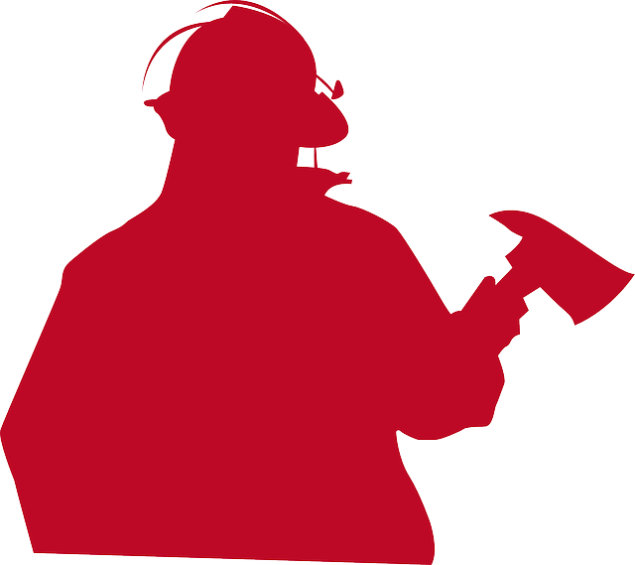

# Frequently Asked Questions



If I am unsuccessful during this round of recruitment, will my application remain on file for future competitions?

No, future vacancies will be reposted and candidates must apply to the new competition process.



If I am successful in the recruitment what happens next?

All successful applicants are ranked in order commencing with the highest scoring and placed on the CBFD’s eligibility list. From this list the next relief firefighters are selected. The eligibility list will expire after an 18-month period. Candidates remaining on the list at that time will be contacted and encouraged to reapply during the next round of recruitment.



If I move into a position of Relief Firefighter, when can I expect to become a full-time employee?

There is no easy way to predict the time that it takes to move from the position of relief firefighter to full-time firefighter. All full-time vacancies are filled from the relief firefighter pool. Full time vacancies become available through the natural course of employment such as retirements, illness, other employment opportunities, etc.

